3B Luna Phone In Compliance Instructions
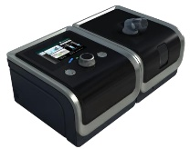
Your device should look like this:

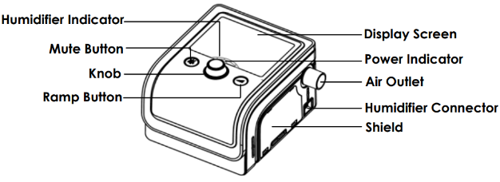

- Turn the control knob to activate the screen
- Press and release the Mute button
- Turn the control knob until iCode 30 is displayed in the left upper corner
  - iCode 30 Click or tap here to enter text.
- Turn the control knob until iCode 90 is displayed in the left upper corner
  - iCode 90 Click or tap here to enter text.
- Email the data back to us or call us at 1-877-753-3742, ext. 2607 or ext. 2603

