3B RESmart Download Instructions
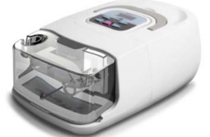
Your device should look like this:
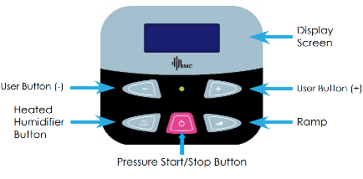

Press the humidifier button to retrieve your iCode® string.

- Continuously pressing the humidifier button steps through all iCode® values. Please enter the following values:
  - iCode® 30 day Click or tap here to enter text.
  - iCode® 90 day Click or tap here to enter text.
- Please email those back to us or call us at 1-877-753-3742, ext. 2607 or ext. 2603.

