Phone In Compliance - Philips Respironics DreamStation
**Please make sure that your machine is plugged in and take out the modem, which is located on the left side of the machine. You will need to lift the lid to access it. (You have to remove the modem in order to complete a phone in compliance).
Once the modem has been removed, turn the control knob and select My Provider 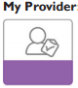in the home screen. Press and release the control knob.
- If the screen is not on, press and release the white push dial to right of the screen to turn it on.
- Turn the push dial until the My Provider menu is on the screen, then press and release the push dial.
- Turn the push dial until Compliance is highlighted. Write down the following:
  - Start Date:
  - Day > 4:
  - Check code:
- Turn the push dial until Phone In is highlighted.
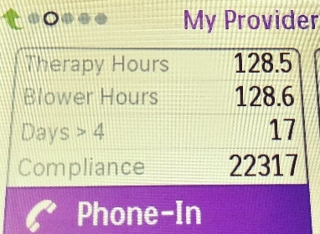
Write down the following:
  - Today’s Date:
  - Total Therapy Hours:
  - Total Blower Hours:
  - Total Days > 4:
  - Compliance:
- Turn the push dial until Main Menu tile is on the screen, then press and release the push dial to go to the Main Menu,
- Turn the push dial until My Info is highlighted.
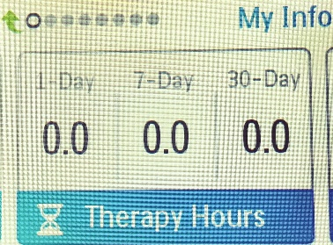
- Go to the Therapy Hours screen and write down the following:
  - Therapy Hours – 7 Day:
  - Therapy Hours 30 Day:
- Email this back to us or call us at 1-877-753-3742, ext. 2229.

