REMStar SE Compliance Steps
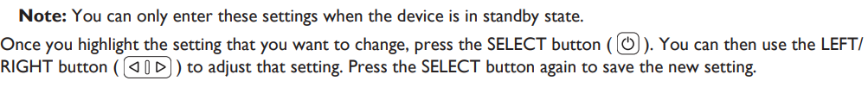
Step 1
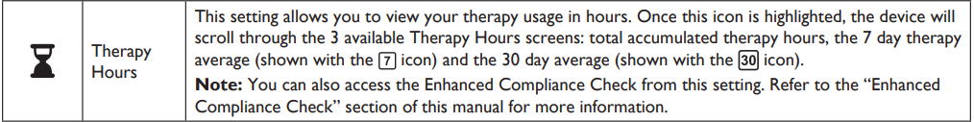
Step 2
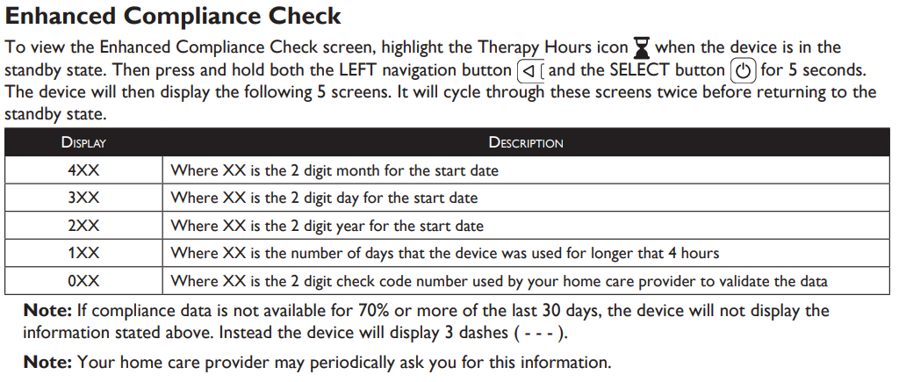

2 digit month - (4)**
2 digit day (3)**
2 digit year(2)**
Days greater than 4 hours (1)**
Check code (0)**

